CSE4/560

Databases and Query Languages

Homework 3

Total Marks 120

Your Name: Manasa Sai Challa

Your email ID: manasasa@buffalo.edu

Your UB Person ID: 50356441

1. [6] Discuss the strengths and weaknesses of the trigger mechanism. Contrast triggers with other integrity constraints supported by SQL.

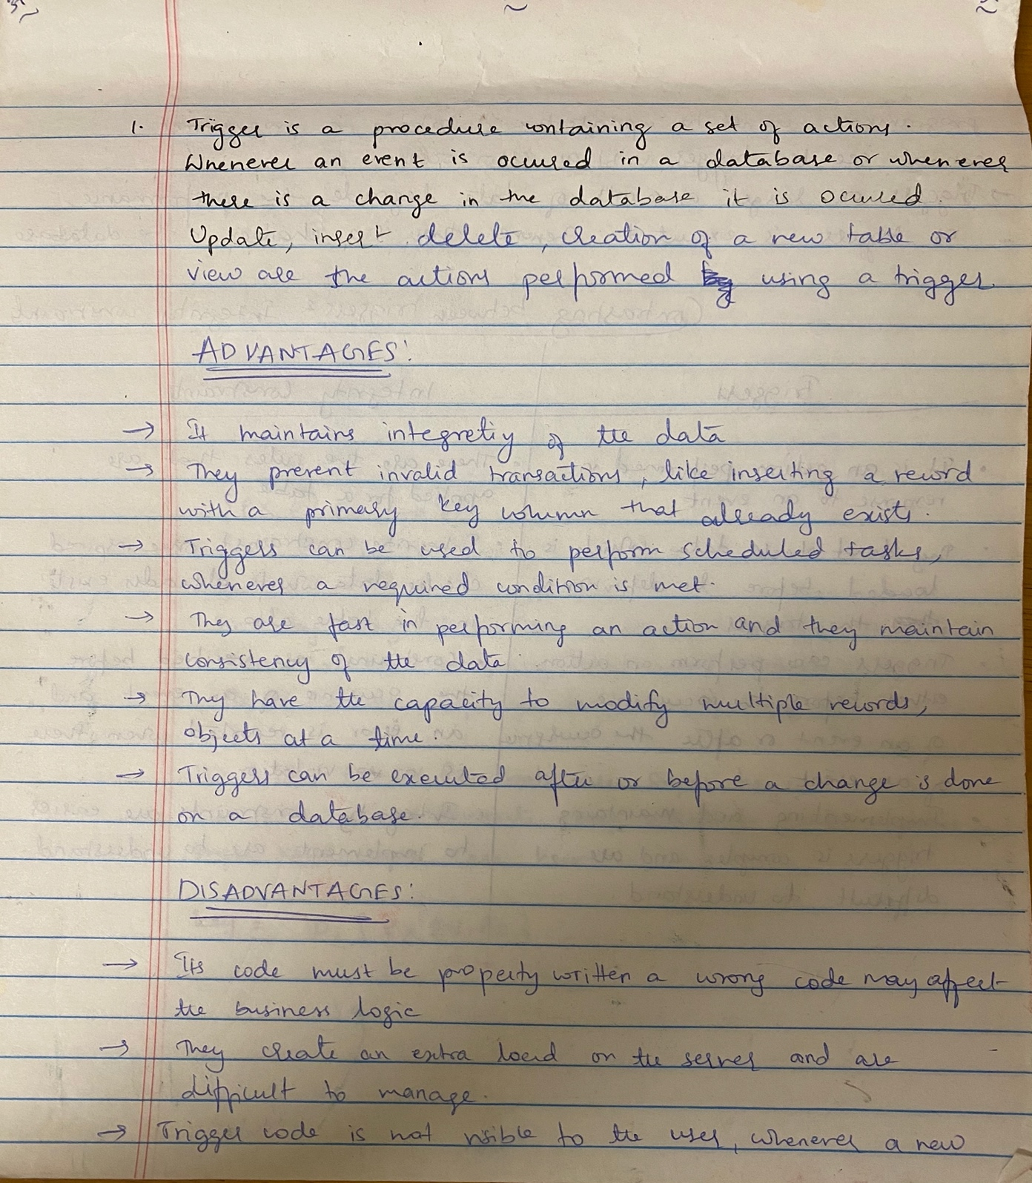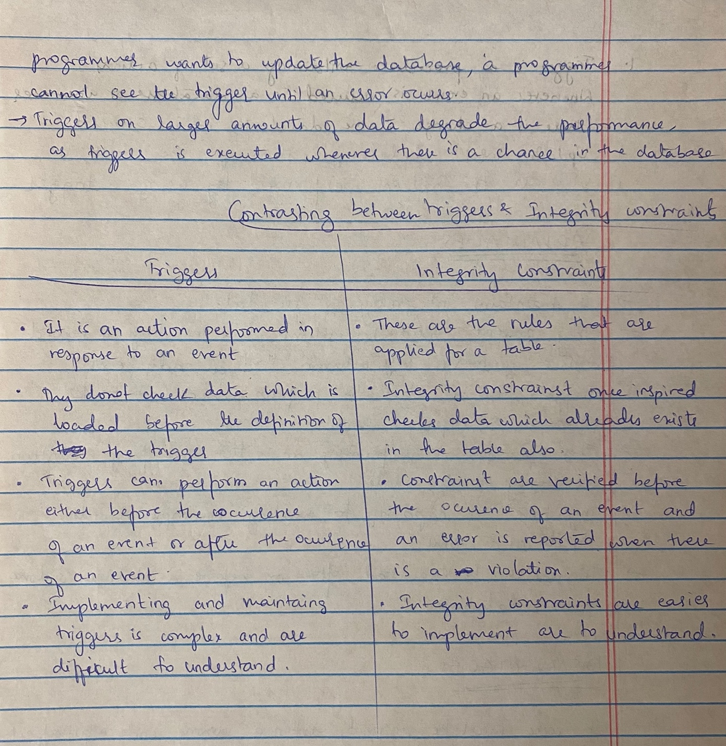

1. [10] Consider a relation about people in the United States, including their name, Social Security number, street address, city, state, ZIP code, area code, and phone number (7 digits). What FD’s would you expect to hold? What are the keys for the relation? To answer this question, you need to know something about the way these numbers are assigned. For instance, can an area code straddle two states? Can a ZIP code straddle two area codes? Can two people have the same Social Security number? Can they have the same address or phone number?

3.[6] Consider a relation representing the present position of molecules in a closed container. The attributes are an ID for the molecule, the x, y,and z coordinates of the molecule, and its velocity in the x, y, and z dimensions. What FD’s would you expect to hold? What are the keys?

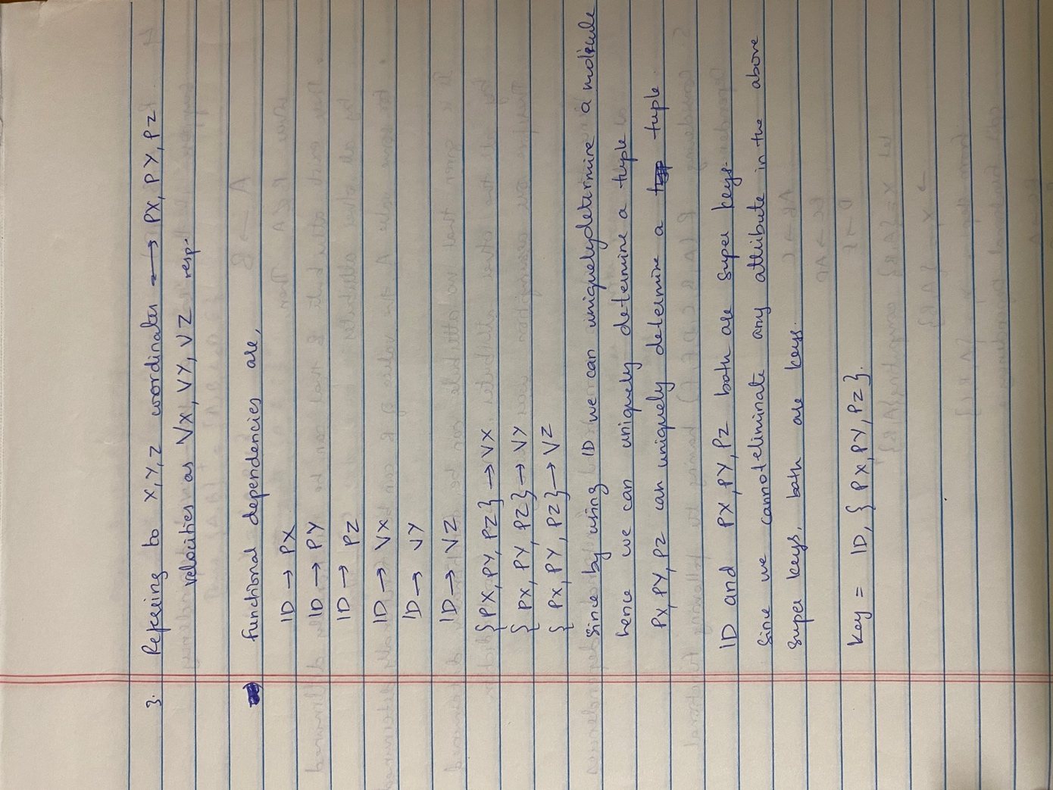

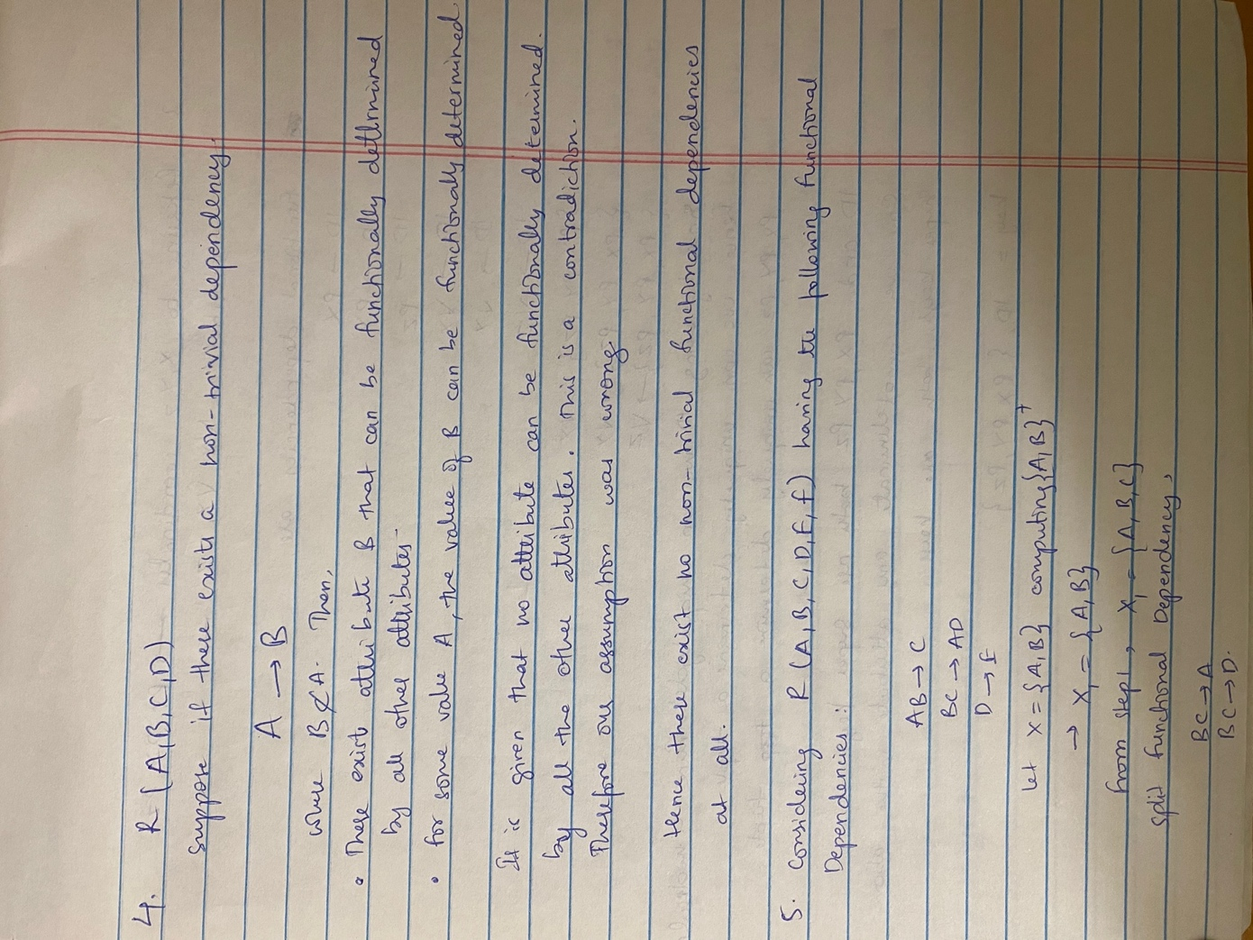4. [6] Show that if a relation has no attribute that is functionally determined by all the other attributes, then the relation has no nontrivial FD’s at all.





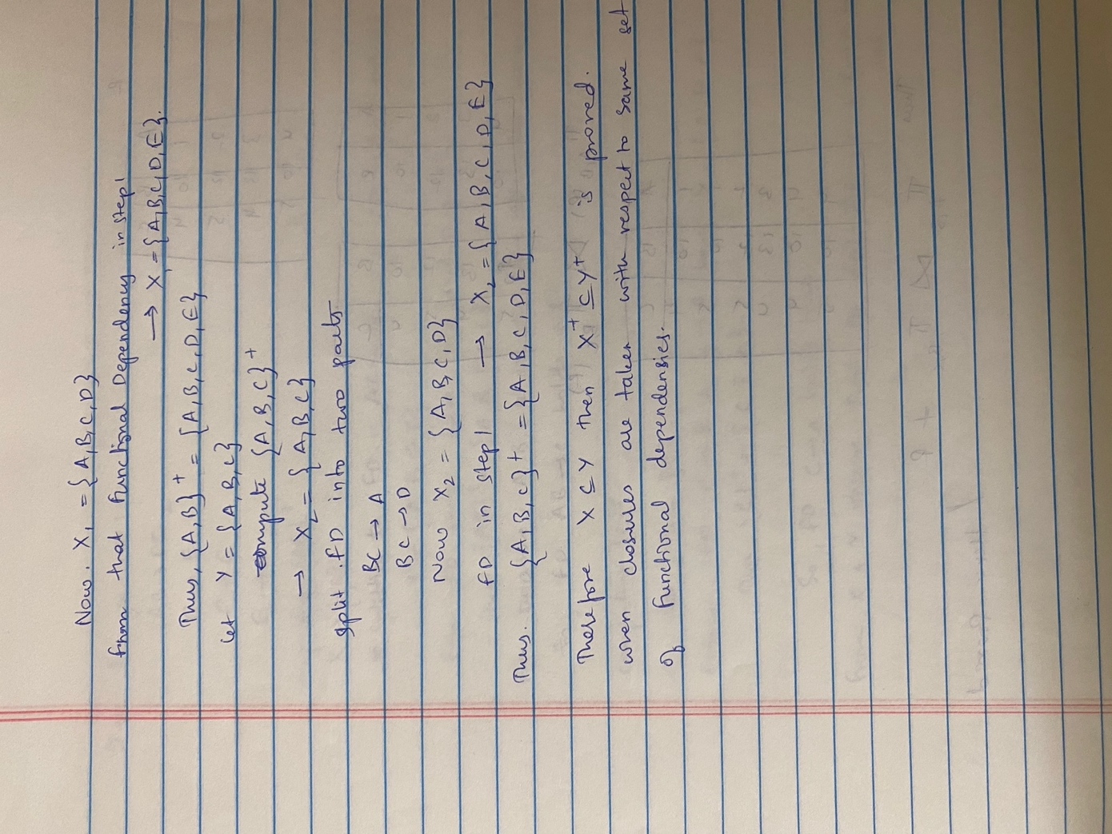

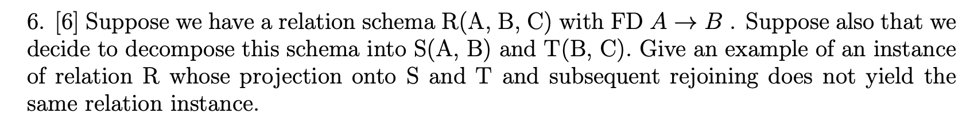

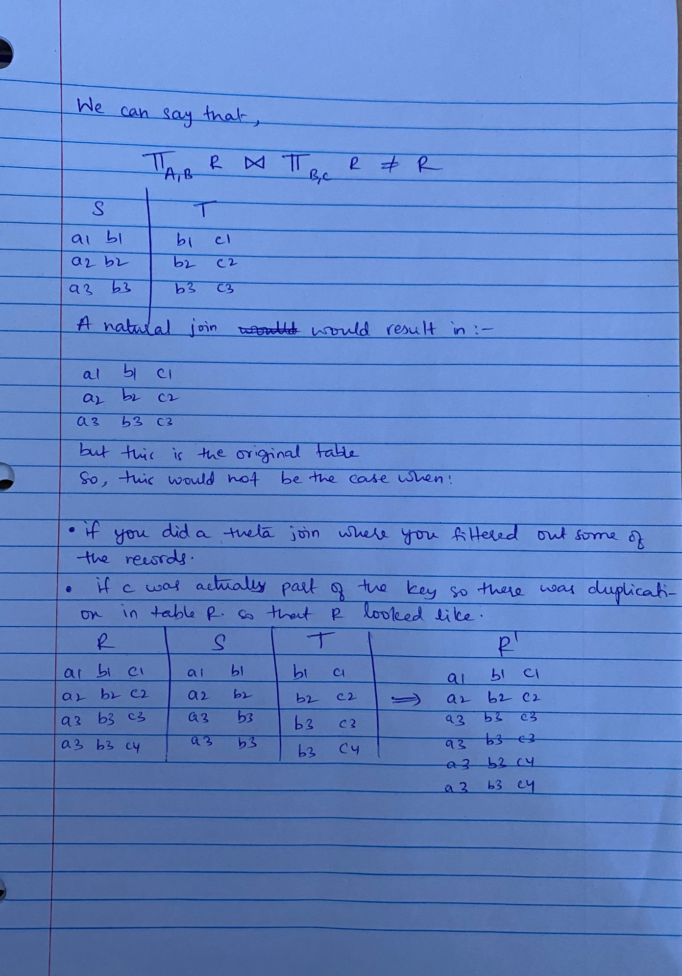

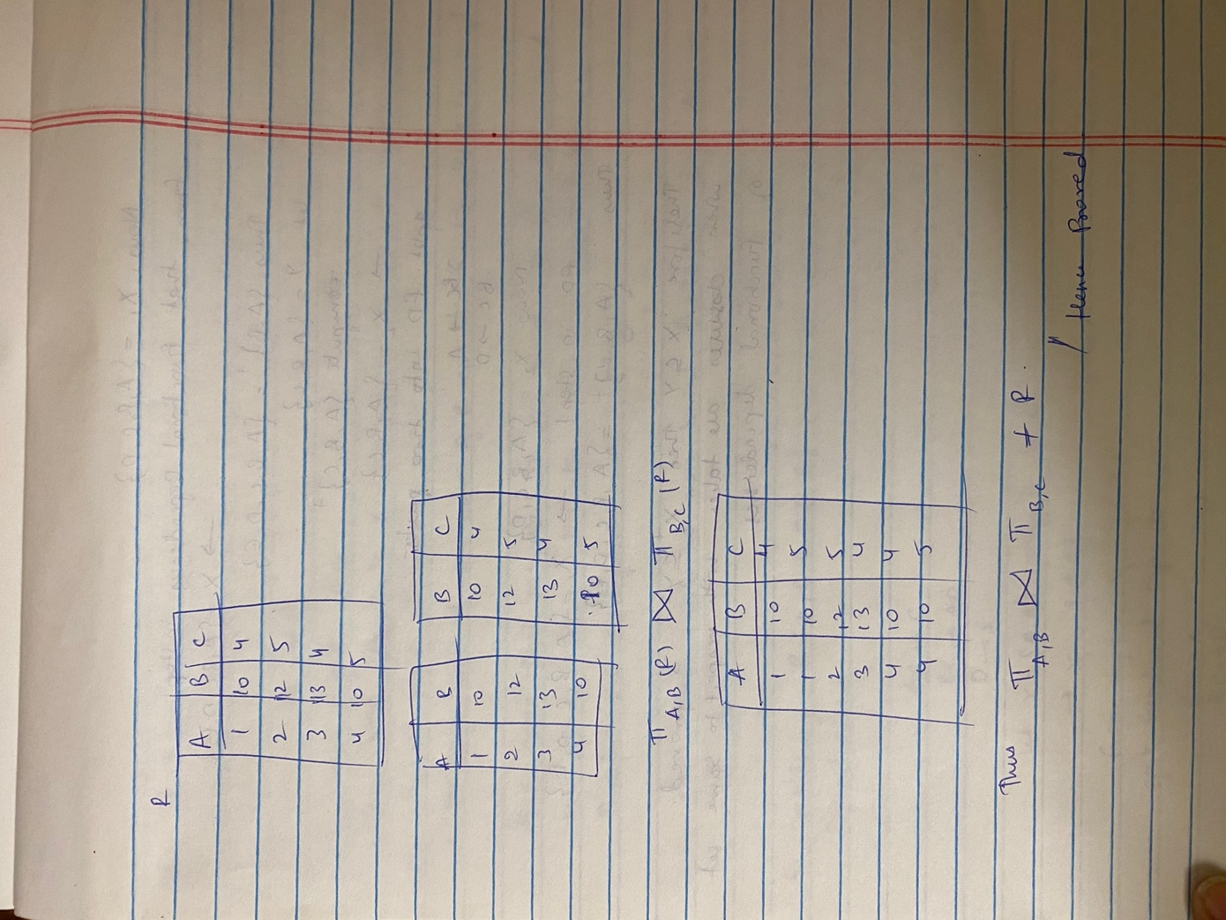

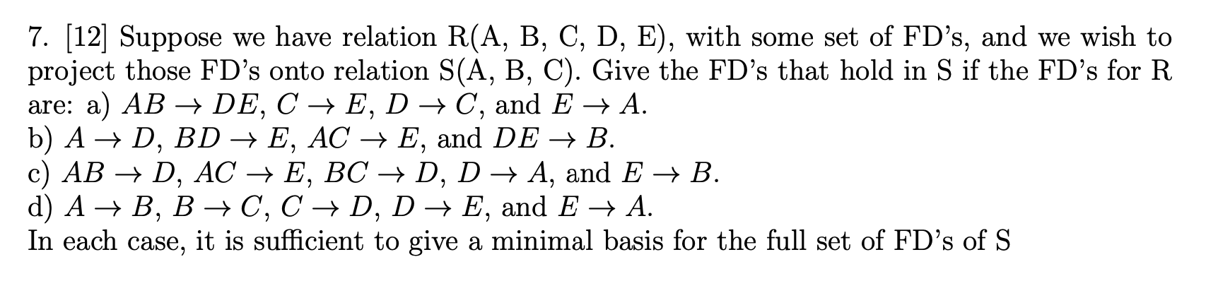

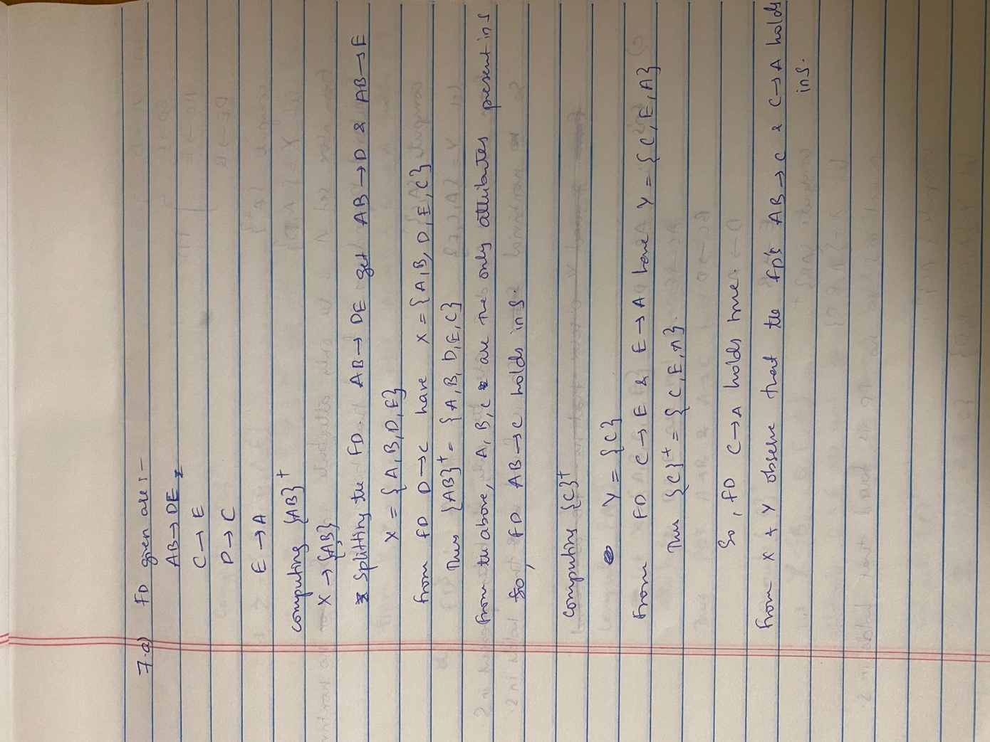

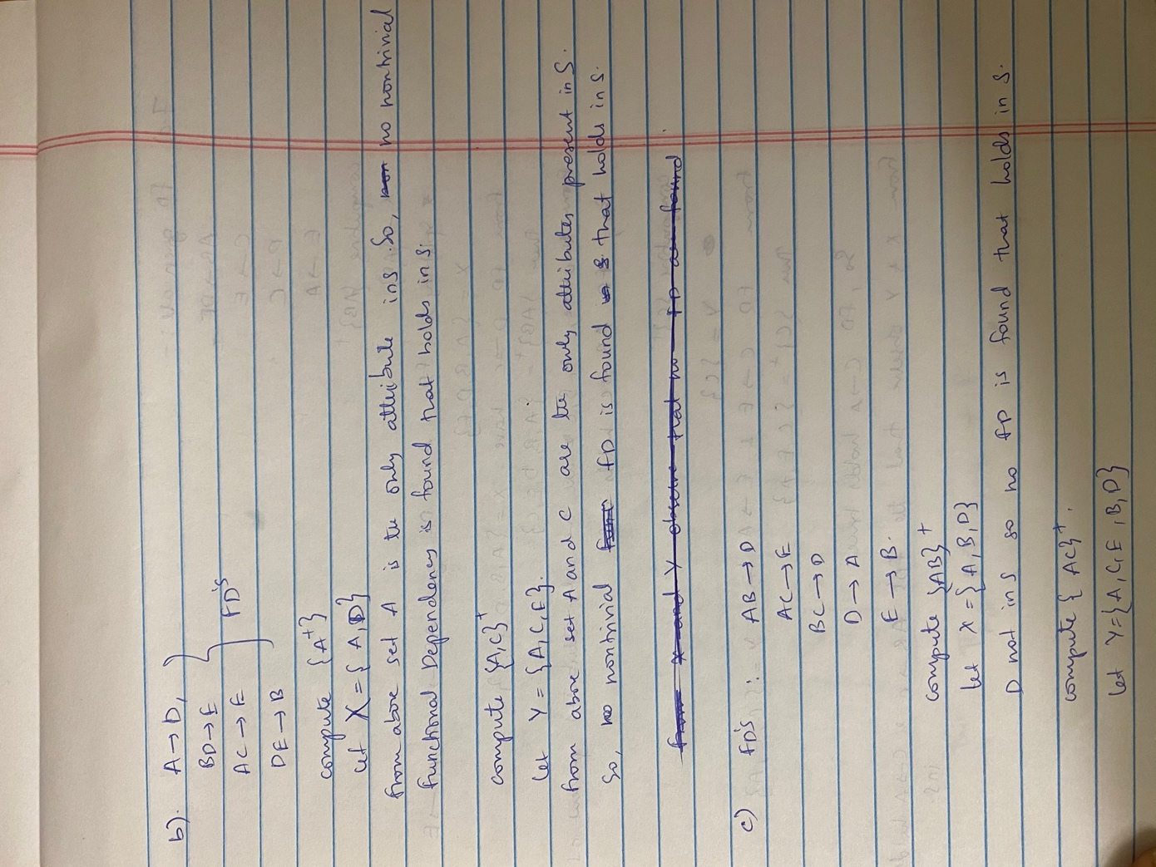

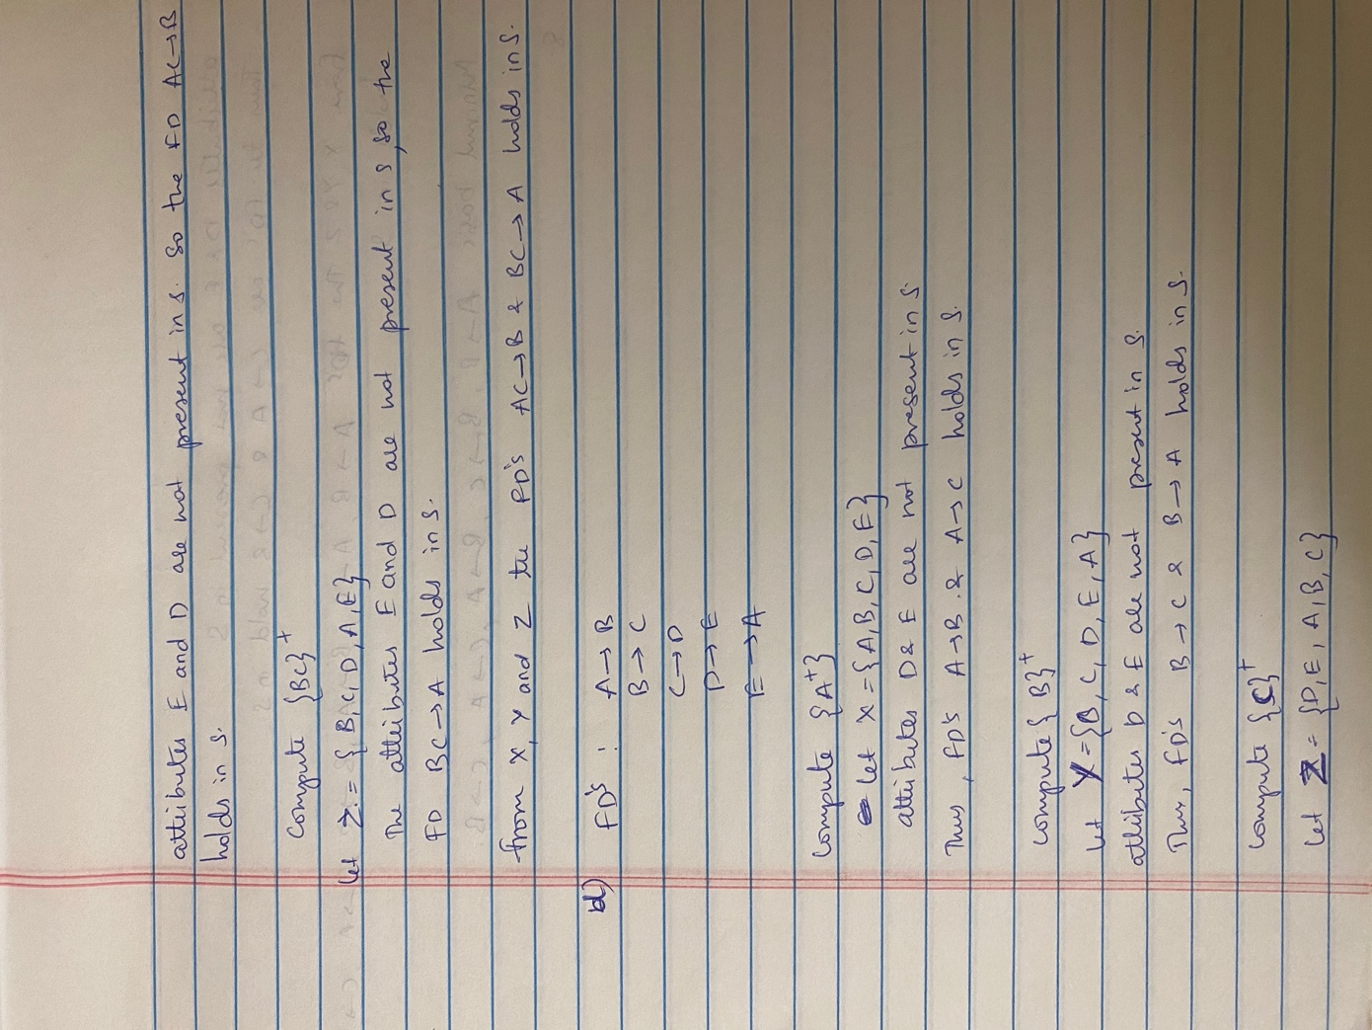

8. [12] Write the following constraints for attributes of the relation: Movies (title , year, length , genre, studioName, producerC)

1. The year cannot be before 1915.

CREATE TABLE Movies(

title varchar(50) NOT NULL,

year int CHECK (year >= 1915),

length int,

genre varchar(100),

studioName varchar(100),

producerC# varchar(50)

);

1. The length cannot be less than 60 nor more than 250.

CREATE TABLE Movies(

title varchar(50) NOT NULL,

year int ,

length int CHECK (length >= 60 AND length <= 250),

genre varchar(100),

studioName varchar(100),

producerC# varchar(50)

);

1. The studio name can only be Disney, Fox, MGM, or Paramount.

CREATE TABLE Movies(

title varchar(50) NOT NULL,

year int,

length int(50),

genre varchar(100),

studioName varchar(100) check(studioname in (‘Disney’,’fox’,’Mgm’,’paramount’)),

producerC# varchar(50)

);

9. [12] Write the following constraints on attributes from the below schema

*Product(maker, model, type)*

*PC(model, speed, ram, hd, price )*

*Laptop(model, speed, ram, hd, screen , price )*

*Printer(model, color, type, price)*

1. The speed of a laptop must be at least 2.0.

ALTER TABLE Laptop(ADD CHECK (speed >=2.0));

1. );The only types of printers are laser, ink-jet, and bubble-jet.

ALTER TABLE Printer(ADD CHECK (type in (‘laser’,’ink-jet’,’bubble-jet’)));

1. The only types of products are P C ’s, laptops, and printers.

ALTER TABLE Product(

ADD CHECK (type in (‘PC’, ’laptop’, ’printers’))

);

1. A model of a product must also be the model of a PC, a laptop, or a printer.

Alter table Laptop add foreign key (model) references Product(model)

Alter table Printer add foreign key (model) references Product(model)

Alter table PC add foreign key (model) references Product(model)

10. [12] Write the following constraints as tuple-based CHECK constraints on one of the relations of our running movies example:

*Movies (title , year, length , genre, studioName, producerC)*

*StarsIn (movie Title , movieYear, starName)*

*MovieStar(name, address, gender, birth date )*

*MovieExec(name, ad d ress, c e rt , netWorth)*

*Studio(nam e, ad d ress, presC)*

If the constraint actually involves two relations, then you should put constraints in both relations so that whichever relation changes, the constraint will be checked on insertions and updates. Assume no deletions; it is not always possible to maintain tuple-based constraints in the face of deletions.

1. A star may not appear in a movie made before they were born.

Alter table StarsIn(ADD check (movieYear>=select YEAR(birthdate) from MovieStar where name=starName))

1. No two studios may have the same address.

Alter table Studio s1 add check (s1.address not in (select address from Studio s2 where s1.name!=s2.name))

1. A name that appears in MovieStar must not also appear in MovieExec.

ALTER TABLE MovieStar ADD CHECK (name NOT IN(SELECT name FROM MovieExec));

1. A studio name that appears in Studio must also appear in at least one Movies tuple.

Alter table Studio add foreign key (name) add check references Movies(studioName)

11. [12] Show how to alter your relation schemas for the movie example:

*Movie (title , year, length , genre, studioName, producerC)*

*Starsln (movie Title , movieYear, starName)*

*MovieStar(name, ad d ress, gender, birth date )*

*MovieExec(name, address, cert , netWorth) Studio(nam e, address, presC)*

in the following ways.

1. Make title and year the key for Movie.

ALTER TABLE Movie ADD CONSTRAINT MovieKey PRIMARY KEY (title, year);

1. Require the referential integrity constraint that the producer of every movie appear inMovieExec.

ALTER TABLE Movie ADD FOREIGN KEY(ProducerC#) REFERENCES MovieExec(name);

1. Require that no movie length be less than 60 nor greater than 250.

ALTER TABLE Movie ADD CHECK (length>60 AND length<250);

d) Require that no name appear as both a movie star and movie executive (this constraint need not be maintained in the face of deletions).

ALTER TABLE MovieStar ADD CONSTRAINT c1

CHECK (name NOT IN (SELECT name FROM MovieExec));

ALTER TABLE MovieExec ADD CONSTRAINT c2

CHECK (name NOT IN (SELECT name FROM MovieStar));

e) Require that no two studios have the same address.

Alter table Studio s1 add check (s1.address not in (select address from Studio s2 where s1.name!=s2.name))

12. [12] Write the following assertions. The database schema is from the “PC ” example of Q9 above:

*Product(maker, model, type)*

*PC(model, speed, ram, hd, price )*

*Laptop(model, speed, ram, hd, screen , price )*

*Printer(model, color, type, price)*

1. No manufacturer of PC ’s may also make laptops.

CREATE ASSERTION NoPCsAndLaptops CHECK (NOT EXISTS

(SELECT P.maker  
FROM PC P, Product Prod WHERE P.model = Prod.model)

INTERSECTS (SELECT P.maker

FROM Laptop L, Product Prod WHERE L.model = Prod.model)

);

CREATE ASSERTION makeLaptops  
CHECK (NOT EXISTS (  
    SELECT maker  
    FROM Product  
    WHERE type = 'pc'  
        AND maker IN(  
            SELECT maker  
            FROM Product  
            WHERE type = 'laptop'  
        )  
));

1. A manufacturer of a PC must also make a laptop with at least as great a processor speed.

CREATE ASSERTION LaptopAtLeastAsFast CHECK (NOT EXISTS

(SELECT *  
FROM PC P, Product Prod1  
WHERE P.model = Prod1.model AND NOT EXISTS

(SELECT *  
FROM Laptop L, Product Prod2  
WHERE L.model = Prod2.model AND Prod1.maker = Prod2.maker

AND L.speed >= P.speed))

);

CREATE ASSERTION greatProcSpeed  
CHECK(NOT EXISTS(  
    SELECT maker  
    FROM Product P1 NATURAL JOIN PC  
    WHERE speed > ALL(  
        SELECT speed  
        FROM Product P2 NATURAL JOIN Laptop  
        WHERE P2.maker = P1.maker  
    )  
));

1. If a laptop has a larger main memory than a PC, then the laptop must also have a higherprice than the PC.

CREATE ASSERTION checkHigher  
CHECK(NOT EXISTS(  
    SELECT model  
    FROM Laptop, PC  
    WHERE Laptop.ram > PC.ram AND Laptop.price < PC.price  
));

1. If the relation Product mentions a model and its type, then this model must appear inthe relation appropriate to that type.

CREATE ASSERTION mustAppear  
CHECK( NOT EXISTS(  
    SELECT model  
    FROM Product  
    WHERE (type=='pc' AND model NOT IN (SELECT model FROM PC))  
    OR (type == 'laptop' AND model NOT IN (SELECT model FROM Laptop))  
    OR (type == 'printer' AND model NOT IN (SELECT model FROM printer))  
));

13.[3+3+4] Write the following as triggers. In each case, disallow or undo the modification if it does not satisfy the stated constraint. The database schema is from the “PC” example of Q9 above:

*Product(maker, model, type)*

*PC(model, speed, ram, hd, price )*

*Laptop(model, speed, ram, hd, screen , price )*

*Printer(model, color, type, price)*

1. When updating the price of a PC, check that there is no lower priced PC with the same speed.

CREATE TRIGGER LowerPriceCheck

AFTER UPDATE OF price ON PC

REFERENCING OLD ROW AS OldTuple

NEW ROW AS NewTuple

FOR EACH ROW

WHEN(NOT(NewTuple.price <= ALL(SELECT priceFROM PCWHERE speed = NewTuple.speed)))

BEGIN

DELETE FROM PC

WHERE (model, speed, ram, hd, rd, price) = NewTuple;

INSERT INTO PC VALUES(OldTuple.model, OldTuple.speed, OldTuple.ram,OldTuple.hd, OldTuple.rd, OldTuple.price);

END;

1. When inserting a new printer, check that the model number exists in Product.

CREATE TRIGGET NewPrinterTrigger

AFTER INSERT ON Printer

REFERENCING

NEW ROW AS NewRow,

NEW TABLE AS NewStuff

FOR EACH ROW

WHEN (NOT EXISTS (SELECT * FROM Product

WHERE Product.model = NewRow.model))

DELETE FROM Printer

1. When making any modification to the Laptop relation, check that the average price of laptops for each manufacturer is at least $1500.

**CREATE TRIGGER** Laptop

**SELECT** avg(price), manufacturer **FROM** Laptop

**Declare** avg = **SELECT** price **FROM** Laptop if(avg<1500)